2026 WODONGA SHOW

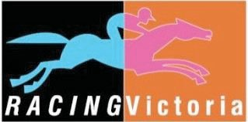
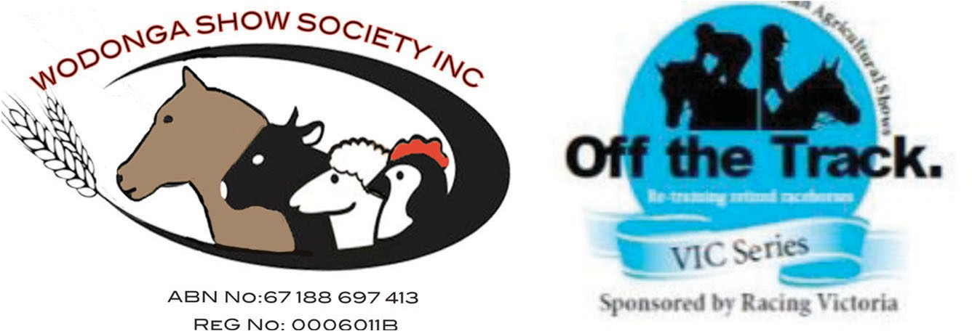

HORSE SCHEDULE
Saturday 21 March 2026
Please note the Event will be held at the Len Hogan Showground Complex
Wilson St, Wodonga

RINGMASTER: Donna Knuckey
Contact No: 0438 860 098

SECRETARY’S OFFICE - SHOWGROUND:
02 60241782
Lot 2 Wilson Street, Cnr Hamilton-Smith Drive, Wodonga
PO Box 54 Wodonga 3689
wodongashow@gmail.org
www.wodongashow.org.au

Wodonga Show Society would like to acknowledge the past and present sponsors for their support of the equestrian events.

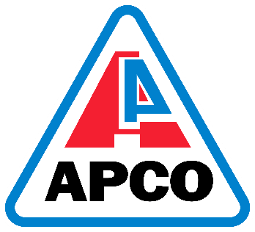






HORSES: SCHEDULE & TIMETABLE OF EVENTS POST ENTRIES ALL HORSE EVENTS
Chief Steward of all Arena & Horse Events Donna Knuckey Phone 0438 860 098
E-mail wodongashow@gmail.com
Judging commences at 9.00 am unless stated otherwise.
All stallions must be equipped with a proper headstall, chain & leading reins & in charge of a competent attendant. The word ‘District’ shall mean a radius of 50km from Wodonga Post Office. Competitors taking part in any Wodonga Show Competition do so at their own risk.
Regulation 25- The Committee reserves the right to alter or omit any items included in the Prize List should same become necessary. A timetable of judging in all classes & events ap- pears in the schedule. When framing the timetable every endeavor has been made to avoid judging of two classes at the same time in which one exhibitor may be interested. Society, however, cannot accept any responsibility if the judging happens to conflict with one or more classes of events. Rings 1, 2 and 3 will be block entry of $20-00 per horse, this enables said horse rider to enter all eligible classes.
No entry allowed to enter outer ring after the commencement of judging.
Wodonga Show Society accepts other States EA measurement certificates. Breeding year dates from 1st August.

All exhibitors must pay at the gate (refer privileges of membership)
Wodonga Show is Affiliated with EFA Victoria Branch.
9.00am Ring 1 Show Horses
9.00am Ring 2 Show Horses
9.00am Ring 3 Stockhorse
9.00am EA Showjumping 5 classes
Certificate of measurements of Led and Ridden exhibits may be requested. Note: No ridden exhibit is eligible to compete for two Champion Sashes.
Horses to compete as Open Hack or Hunter Hack not both
Under no circumstances will there be any changes to this program of events.

Off the Track Series – Qualifiers Regulations

- Open to Thoroughbreds unraced or raced 4 years and over, · over 14.2 hands & who have a RISA (Racing Information Services Australia).
Registrations will be checked.
- Racing/Trial name to be used where appropriate. When entering if name is different to racing name, and the following details (if known)
  - Racing name • Registration Certificate Number
  - Brands, colour and markings • Dam and Sire
  - Microchip number • Date horse retired
  - Life Number •
- Qualifying Shows must be affiliated with VAS Ltd
- Qualifying classes will be judged ridden
- Once a qualifier is won, the horses cannot compete in other qualifiers
- All qualifying winners gain automatic entry into the Off the Track series Final to be held at the VAS Ltd
Saddle Horse Championships.
- Riders to be 14 years and over on day of qualifying show
- To be judged as a good example of Thoroughbreds rather than riding horse/hunter types with the following being taken into consideration:
- Thoroughbred qualities
- Conformation
- Manners, paces and performance
- Injuries caused through racing such as blemishes are allowed
- Judges decision is final in qualifiers and final
- Qualifier Prizes: $50, sash and Racing Victoria Prize Pack

OFF THE TRACK FINAL
- To have qualified at a Qualifying Show in an Off The Track Class
- Horse to be entered in racing name where possible
- Expected to walk, trot and canter with change of rein
- Judge may ride horses in final
- If judge does not ride exhibits, competitors will be asked to do an individual workout and show walk, trot, canter on both reins and gallop finishing with a halt and salute to the judges/s
- Other regulations for Final
  - In the event of one rider going through to the Final with more than one horse they must nominate a substitute rider
  - An exhibitor may not knowingly exhibit a horse that has been bred, sold, leased or produced by the judge or his/her employer
  - An exhibitor may not show a horse judged by any member of his/her immediate family
  - An exhibitor may not show under a judge that they have produced an equine for within the last 24 months

State Prizes: Winner ‐ $1000, Sash & Rug, Runner Up ‐ $500 & Sash, Final 8‐ Sash and Prize pack.
Special Prize for being within and up to 2 Years Off The Track

Ring 1 Horse Events Commencing 9am Judge: Fiona Forge

1 Led Open Hack over 15hh
2 Led Hunter Hack over 15hh
3 Led OTT Open Hack
4 Led OTT Hunter Hack
5 Led Open Galloway
6 Best overall Led exhibit from ring 1 and 2
7 Smartest on Parade 12yrs and under 18yrs
8 Smartest on Parade 18yrs and over
9 Rider 12yrs and under 14yrs
10 Rider 14yrs and under 16yrs
11 Rider 16yrs and under 18yrs
12 Champion & Reserve Rider
13 Rider 18yrs and under 21yrs
14 Rider 21yrs and under 30yrs
15 Rider 30yrs and over
16 Champion & Reserve Rider
17 Ridden Hack 15hh and under 15.2hh
18 Ridden Hack 15.2hh and under 16hh
19 Ridden Hack 16hh and under 16.2hh
20 Ridden Hack over 16.2hh
21 Open Ridden Hack
22 Champion & Reserve Ridden Hack
23 Ridden Hunter Hack 15hh and under 15.2hh
24 Ridden Hunter Hack 15.2hh and under 16hh
25 Ridden Hunter Hack 16hh and under 16.2hh
26 Ridden Hunter Hack over 16.2hh
27 Open Hunter Hack
28 Champion & Reserve Ridden Hunter Hack
29 Ridden Shetland
30 Ridden Pony under 12hh
31 Ridden Pony 12hh and under 12.2hh
32 Ridden Pony 12.2hh and under 13hh
33 Ridden Pony 13hh and under 13.2hh
34 Ridden Pony 13.2hh and under 14hh
35 Open Ridden Pony
36 Champion & Reserve Ridden Pony
37 Ridden Hunter Pony under 12hh
38 Ridden Hunter Pony 12hh and under 12.2hh
39 Ridden Hunter Pony 12.2hh and under 13hh
40 Ridden Hunter Pony 13hh and under 13.2hh
41 Ridden Hunter Pony 13.2hh and under 14hh
42 Open Hunter Pony
43 Champion and Reserve Ridden Hunter Pony
44 Ridden Galloway 14hh and under 14.2hh
45 Ridden Galloway 14.2hh and under 15hh
46 Open Ridden Galloway
47 Champion and Reserve Ridden Galloway
48 Ridden Hunter Galloway 14hh and under 14.2hh
49 Ridden Hunter Galloway 14.2hh and under 15hh
50 Open Ridden Hunter Galloway
51 Champion and Reserve Ridden Hunter Galloway

Ring 2 Horse Events Commencing 9am Judge: Louise Allitt
1 Led Shetland Pony
2 Led Open Pony
3 Led Hunter Pony
4 Led Hunter Galloway
5 Best overall Led exhibit from ring 1 and 2
6 Led Rein Pony under 12hh Rider under 8yrs
7 Smartest on Parade under 12yrs
8 Rider under 6yrs
9 Rider 6yrs and under 8yrs
10 Rider 8yrs and under 10yrs
11 Rider 10yrs and under 12yrs
12 Champion & Reserve Rider under 12yrs
13 Ridden Pony under 12hh
14 Ridden Pony 12hh and under 12.2hh
15 Ridden Pony 12.2hh and under 13hh
15a Champion & Reserve Ridden Pony under 13hh
16 Ridden Pony 13hh and under 13.2hh
17 Ridden Pony 13.2hh and under 14hh
18 Open Ridden Pony
19 Champion & Reserve Ridden Pony
20 Ridden Hunter Pony under 12hh
21 Ridden Hunter Pony 12hh and under 12.2hh
22 Ridden Hunter Pony 12.2hh and under 13hh
22a Champion & Reserve Ridden Hunter Pony under 13hh
23 Ridden Hunter Pony 13hh and under 13.2hh
24 Ridden Hunter Pony 13.2hh and under 14hh
25 Open Ridden Hunter Pony
26 Champion & Reserve Ridden Hunter Pony
27 Ridden Galloway 14hh and under 14.2hh
28 Ridden Galloway 14.2hh and under 15hh
29 Open Ridden Galloway
30 Champion & Reserve Ridden Galloway
31 Ridden Hunter Galloway 14hh and under 14.2hh
32 Ridden Hunter Galloway 14.2hh and under 15hh
33 Open Ridden Hunter Galloway
34 Champion & Reserve Ridden Hunter Galloway
35 Ridden Hack 15hh and under 15.2hh
36 Ridden Hack 15.2hh and under 16hh
37 Ridden Hack 16hh and under 16.2hh
38 Ridden Hack over 16.2hh
39 Open Ridden Hack
40 Champion & Reserve Ridden Hack
41 Off the Track Ridden Thoroughbred
42 Ridden Hunter Hack 15hh and under 15.2hh
43 Ridden Hunter Hack 15.2hh and under 16hh
44 Ridden Hunter Hack 16hh and under 16.2hh
45 Ridden Hunter Hack over 16.2hh
46 Open Ridden Hunter Hack
47 Champion & Reserve Ridden Hunter Hack
48 Off the Track Ridden Hunter Hack
49 Working Hunter Pony
50 Working Hunter Galloway
51 Working Hunter Hack

Ring 3 Led and Ridden Breeds Commencing 9am Judge: Amanda Preedy

All Breeds to be registered with their appropriate breed society

Block entry for all classes $20‐00 for the day Ribbons to 3rd place

Ponies to be 87 cms or under
1. Miniature pony stallion or colt
2. Miniature pony gelding
3. Miniature pony mare or filly
Champion and Reserve Champion Miniature pony Shetlands ne 8.2 hh
4. Shetland pony stallion or colt ne 8.2 hh
5. Shetland pony gelding ne 8.2 hh
6 .Shetland pony mare or filly ne 8.2 hh
Champion and Reserve Champion Shetland pony ne 8.2 hh Shetlands over 8.2 hh and ne 10.2 hh
7. Shetland pony stallion or colt over 8.2 hh and ne 10.2 hh
8. Shetland pony gelding over 8.2 hh and ne 10.2 hh
9. Shetland pony mare or filly over 8.2 hh and ne 10.2 hh
Champion and Reserve Champion Shetland over 8.2 hh and ne 10.2 hh Welsh Mountain Ponies – Section A
10. Stallion or colt
11. Mare
12. Filly 3 years and under
Champion and Reserve Champion Welsh A Welsh Mountain Ponies – Section B
13. Stallion or colt
14. Mare
15. Filly 3 years and under
Champion and Reserve Champion Welsh B Welsh Mountain Ponies – Section C
16. Stallion or colt
17. Mare
18. Filly 3 years and under
Champion and Reserve Champion Welsh C Welsh Mountain Ponies – Section D
19. Stallion or colt
20. Mare
21. Filly 3 years and under
Champion and Reserve Champion Welsh D Welsh Geldings
22. Gelding of Section A breeding
23. Gelding of Section B breeding
24. Gelding of Section C or D breeding
Champion and Reserve Champion Welsh geldings Part Welsh
25. Part Welsh young stock 3 years and under
26. Part Welsh 12.2 hh and under
27. Part Welsh 12.2 hh and ne 13.2 hh
28. Part Welsh 13.2 hh and over
Champion and Reserve Champion part bred Welsh Ridden Shetlands
29. Stallion or colt
30. Gelding
31. Mare or filly
Champion and Reserve Champion ridden Shetlands Australian saddle pony
32. Led male
33. Led female
Champion and Reserve Champion led Australian saddle pony Riding Ponies
34. Led male
35. Led female
Champion and Reserve Champion led riding pony Arabian Derivative
36. Led male
37. Led female
Champion and Reserve Champion Arabian derivative Led Purebred APSB (Connemaras, New Forest, Highland, Australia, Shetland)
38. Led purebred mare or filly under 14 hh
39. Led purebred male under 14 hh
Champion and Reserve Champion led pure bred APSB Led Partbred APSB
40. Led female
41. Led male
Champion and Reserve Champion led part bred APSB Coloured Classes
42. Led colt, filly or gelding 3 years and under
43. Led mare over 3 years
44. Led gelding over 3 years
Champion and Reserve Champion Coloured Classes Ridden Riding Pony
45. Male under 14.2 hh
46. Female under 14.2 hh
Champion and Reserve Champion ridden riding pony Ridden Saddle Pony
47. Male
48. Female
Champion and Reserve Champion ridden saddle pony Ridden Arabian Derivatives
49. Male
50. Female
Champion and Reserve Champion ridden Arabian derivatives Ridden Welsh
51. Section A, B, C or D - Mare
52. Section A, B, C or D - Gelding
53. Section A, B, C or D – Stallion
Champion and Reserve Champion ridden Welsh Ridden Part Welsh
54. Ridden ne 12.2 hh
55. Ridden over 12.2 hh and ne 13.2 hh
56. Ridden over 13.2 hh
Champion and Reserve Champion ridden part Welsh Ridden purebred APSB
57. Ridden gelding
58. Ridden mare
Champion and Reserve Champion ridden purebred APSB Ridden part bred APSB
59. Ridden gelding
60. Ridden mare
Champion and Reserve Champion ridden part bred APSB Ridden Coloured
61. Ridden male
62. Ridden female
Champion and Reserve Champion ridden coloured Standard Breds
63. Led male
64. Led female
Champion and Reserve Champion standard breds Heavy Horses
65. Led heavy horse male
66. Led heavy horse mare or filly
Champion and Reserve Champion heavy horse Standard Breds Ridden
67. Ridden male
68. Ridden female

Champion and Reserve Champion ridden standard bred

SHOW JUMPING 2026

Showjumping will be a Closed Restricted Event under the following format as per article 100 in EA General Regulations.
This event is open to Wodonga Show Society Members and/or invited EA members. EA members will need to hold the appropriate membership category i.e. participant or competitor, and as a minimum hold base horse registration. If you are participating as an invited EA member, please have proof of membership and registration available when you place your entries.

Day membership of the Wodonga Show Society is $10-00.

This year’s program will consists of 5classes 65 cm 238 2.2
75cm | 238 2.2
85cm | 238 2.2
95cm | 238 2.2
104cm238 2.2

All Classes $10 entry fee, Prize Money $40, $30, $20, $10 Maximum of 2 starts per Horse.
The Committee reserves the right to alter the Program if necessary.

THANK YOU
to our generous sponsors and Friends of the Wodonga Show Society!

