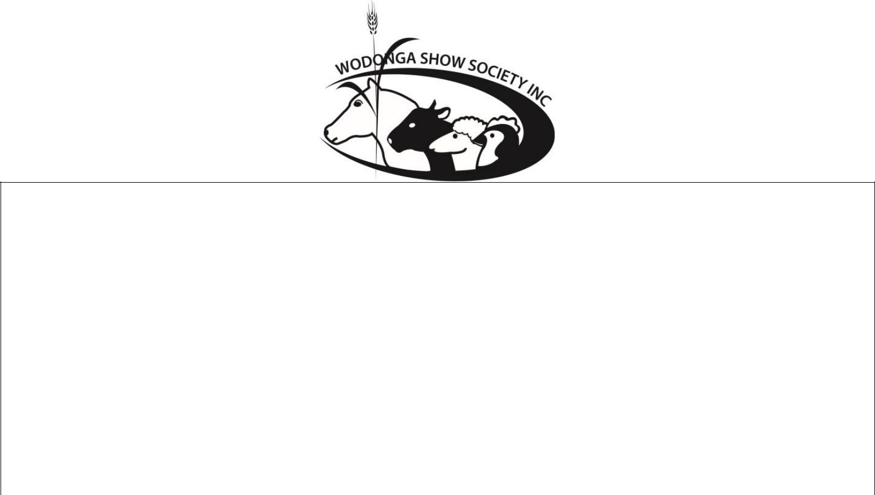

Wodonga 2026 Annual Show

SHOW DAY SATURDAY 14th MARCH 2026

CATTLE SCHEDULE
- Small Breed Classes
- Commercial Steer and Heifer Classes
Look for updates at www. wodongashow.org.au

Contact steward Ruth Nicholls - 0411 260 568

ALL EXHIBITORS TO ENTER THE SHOWGROUNDS VIA RICHARDSON STREET GATE.

ENTRY FEE: $ 15.00 per Exhibit. LATE FEE: $20.00

Late entries will only be accepted with an increased fee of $20.00

To avoid paying late fees - Entries close on Thursday 12th March 2026 at 5.00 pm

Judging commence approx. 9.30am. Saturday 14th March 2026.

Exhibitors to provide bales required.

CATTLE SECTION RULES & REGULATIONS:

- The breeding dates of all cattle entered for the Wodonga Show, which is an Autumn Show, is calculated as being 1st March in each year.

- Only one exhibitor will be recognised as an owner from any one holding, and any exhibitor who enters, or permits the entry of any of his/her Stock, in the name of any other exhibitor, shall be disqualified.

- Any exhibitor who shall, without due cause, fail to parade any animal before the judge when required to do so by the Steward of the Section, shall be disqualified.

- If, in the opinion of the Committee, any exhibits are deemed dangerous, the owner of such exhibits shall immediately, upon notice to that effect, remove such exhibits from the Society’s grounds.

5(a) All male exhibits of cattle over the age of twelve (12) months shall be ringed through the nose, and when on parade or going to and from shall be led by such ring.

5(b) All cattle over six (6) months to have nose clips

6 All Cattle must be led and able to tie up.

7 Each exhibitor is required to see that each of his exhibits is securely tethered in its stall and be tethered by halter and neck strap.

8 All exhibits are shown and stalled at risk of the exhibitor and no responsibility can be accepted by the Society in respect to these exhibits.

9 In ‘OPEN’ female classes, only calves up to 8 (eight) months can be paraded with the dam.

10 Prize money will be available for collection after 1.30pm on the day of the Show

11 NO prefixes to be worn to identify both animal and leader during the judging.

12 Copies of the registration certificate of all animals, to be submitted with your entries.

13 All cattle are to be tagged with NLIS tags. Animals will be scanned and information uploaded onto NLIS database to show that cattle were sighted on Showground.

14 Prize money will be determined based on the number of entrants in each class.

15 Classes 1 to 18 are for Cattle registered with a recognised Beef Breed Society while classes 19 and 20 are for led commercial heifers and steers.
Cattle Classes

Class 1- Female under 12 months
Class 2- Female 12 months and under 15 months
Class 3- Female 15 months and under 18 months
Champion Junior Female
Reserve Champion Junior Female

Class 4- Female 18 months and under 24 months
Class 5- Female over 24 months
Champion Senior Female
Reserve Champion Senior Female

Champion Female

Reserve Champion Female

Class 6- Bull under 12 months
Class 7- Bull 12 months and under 15 months
Class 8- Bull 15 months and under 18 months
Champion Junior Bull
Reserve Champion Junior Bull

Class 9- Bull 18 months and under 24 months
Class 10- Bull over 24 months
Champion Senior Bull
Reserve Champion Senior Bull

Champion Bull
Reserve Champion Bull

Supreme Champion Exhibit

Small Breed Classes

Class 11- Female under 15 months
Class 12- Female 15 months and under 18 months
Champion Junior Female
Reserve Champion Junior Female

Class 13- Female 18 months and under 24 months
Class 14- Female over 24 months
Champion Senior Female
Reserve Champion Senior Female

Champion Female

Reserve Champion Female

Class 15- Bull under 15 months
Class 16- Bull 15 months and under 18 months
Champion Junior Bull
Reserve Champion Junior Bull

Class 17- Bull 18 months and under 24 months
Class 18- Bull over 24 months
Champion Senior Bull
Reserve Champion Senior Bull

Champion Bull
Reserve Champion Bull

Supreme Champion Small Breed Exhibit

Commercial Steer or Heifer Competition

Class 19- Any beef steer or heifer under 12 months

Class 20- Any beef steer or heifer over 12 months

Champion Commercial Steer or Heifer

JUNIOR BEEF PARADER’S COMPETITION
This event will commence immediately after the Commercial Steer or Heifer Competition
ALL AGES TO BE APPLICABLE ON 1st May 2026

21 Junior Paraders Section:
Competitors to be 8 yrs under 15 years of age on 1st May 2026.

22 Open Paraders Section:
Competitors to be 15 years and not more than 25 years on 1st May 2026

Champion Junior Parader
Reserve Champion Junior Parader

Please note- Classes may be split based on availability of animals and numbers of competitors.

JUNIOR JUDGING COMPETITION

This event will commence immediately after Beef Paraders’ Competition
ALL AGES TO BE APPLICABLE ON 1st May 2026
23 Junior Section:
8 yrs. and Under 15 years of age on Saturday 1st May 2026

24 Open Section:
Competitors 15 years and not more than 25 years on 1st May 2026

Champion Junior Judge
Reserve Champion Junior Judge

Please note- Classes may be split based on availability of animals and numbers of competitors.
Note** Competitors can only win one qualification for Royal Melbourne Show. **

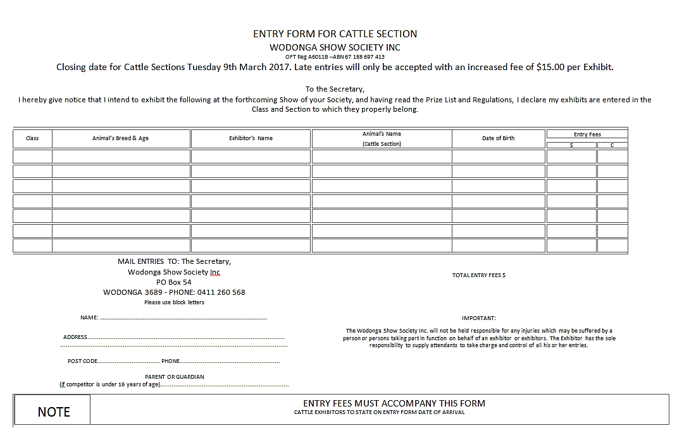
Thursday 12th March 2026 5.00 pm

VAS ENTRY FORM
BEEF CATTLE JUDGING COMPETITION □
BEEF CATTLE PARADER’S COMPETITION □
Age 8 – 15 years (As at 1st May in year of State Final) SHOW SOCIETY:……………………………
Date of Event: ………………………………. GROUP FINAL: ………………………………
STATE FINAL: ……………………………….
COMPETITOR NAME:………………………………………………………………………………
ADDRESS:……………………………………………………………………………………………
DATE OF BIRTH:………………………… PHONE NO:…………………………………
- - - - - - - - - - - - - - - - - - - - - - - - - - - - - - - - - - - - - - - - - - - - - - - - - - - - - - - - - - - - - - - - - -
Have you been placed at another show or group Final since the last Royal Melbourne Show?
YES/NO (please circle whichever is applicable)
If yes, please state name of Show Society/Group………………………………………………
NOTE: IF COMPETITORS HAVE WON AT A SHOW WITHIN THE SHOW SEASON THEY CAN COMPETE IN OTHER SHOWS FOR EXPERIENCE ONLY, THEY CANNOT BE PLACED 1ST OR 2ND.

……………………………………………………………………………………………………………………………………………………………
VAS ENTRY FORM
BEEF CATTLE JUDGING COMPETITION □
BEEF CATTLE PARADER’S COMPETITION □
Age 8 – 15 years (As at 1st May in year of State Final) SHOW SOCIETY:……………………………
Date of Event: ………………………………. GROUP FINAL: ………………………………
STATE FINAL: ……………………………….
COMPETITOR NAME:………………………………………………………………………………
ADDRESS:……………………………………………………………………………………………
DATE OF BIRTH:………………………… PHONE NO:…………………………………
- - - - - - - - - - - - - - - - - - - - - - - - - - - - - - - - - - - - - - - - - - - - - - - - - - - - - - - - - - - - - - - - - -
Have you been placed at another show or group Final since the last Royal Melbourne Show?
YES/NO (please circle whichever is applicable)
If yes, please state name of Show Society/Group………………………………………………
NOTE: IF COMPETITORS HAVE WON AT A SHOW WITHIN THE SHOW SEASON THEY CAN COMPETE IN OTHER SHOWS FOR EXPERIENCE ONLY, THEY CANNOT BE PLACED 1ST OR 2ND.

